# IN628 Programming 4

# Semester 1, Practice Exam 2019

1. Consider the following C++ code:

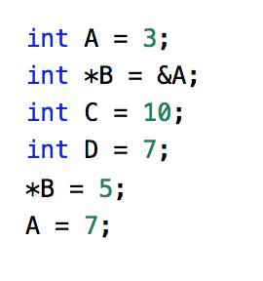

* 1. After execution, what is the value of A?
  2. What is the value of B*?

1. In pseudocode, describe how you would reverse a singly linked list.
2. In pseudocode, describe how you would you delete the middle item in a singly linked list.
3. Consider the following Prolog knowledge base. What is the result of the following queries?

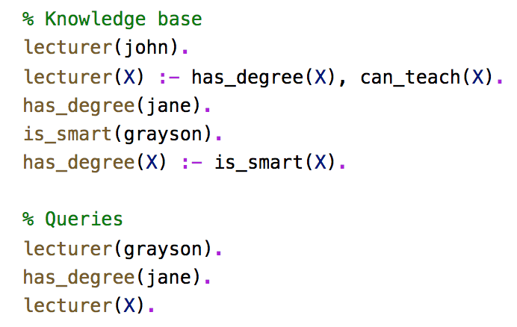

1. Consider the following Python code:

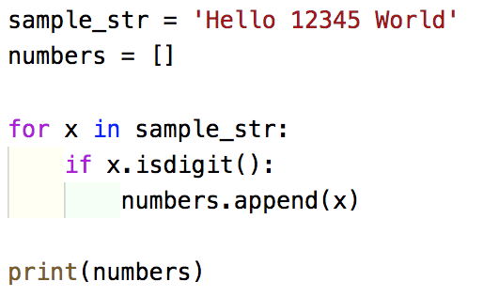

* 1. Rewrite the code above to use a list comprehension to generate the numbers list.
  2. Rewrite the code above to use a map and lambda function to generate the numbers list.

1. Describe what a Python iterator is and how it works.
2. Ever alert to current trends, you are building a new arcade-style game about a superhero called “Captain Sustainability”. In this game, the player controls Captain Sustainability as he battles the evil Dr. Polluto. The Dr. Polluto character roams about the game world. At intervals of between 10 and 50 game cycles he stops roaming and drops some rubbish onto the ground (he has a sprite sheet for this). He then continues to roam. As rubbish accumulates, the earth’s temperature rises. Captain Sustainability must pick up the rubbish. If he cannot do so before the earth’s temperature gets too high, all the Spotted Owls in the world will die. If Captain Sustainability comes within Dr. Polluto’s range, Dr. Polluto will shoot at him with the Fluorocarbon-Emitting Hairspray Can of Doom. If Dr. Polluto gets a hit, he stands and laughs evilly for a while (he has a sprite sheet for this) before continuing to roam; if Dr. Polluto misses, he simply resumes roaming.
   1. Sketch an FSM for the behaviour of Dr. Polluto. Be sure to label your diagram clearly. Be careful to include only those features of the game as described above which belong in Dr. Polluto’s FSM.
3. In a University, you have employees and students. Both employees and students have a name, age and sex. An employee has a salary, but a student has a loan, student id and GPA. Sketch a diagram of the class architecture you would use for this scenario, showing the methods defined in each class (don’t write any code). Be sure to clearly indicate any inheritance relationships.
4. Describe the following paradigms:
   1. Logical
   2. Declarative
   3. Functional
   4. Imperative
5. Consider the following Python slice operator code:

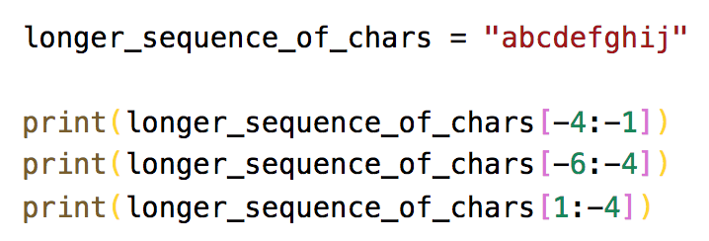

* 1. What is the result of each print statement?

1. Describe the four terms (variables, atoms, numbers and compound terms) in Prolog.
2. Complete the following Python statements:
   1. If a data member is created outside any method, they are __________
   2. If a data member is created inside a method without prefix, they are __________
   3. If a data member is declared inside a method and prefaced with self, they are __________
3. You are designing an RPG with a player that shoots Bullets in a single direction. If a Bullet hits an enemy, the Enemy is destroyed. The player can shoot multiple Bullets in rapid succession, and there are hundreds of Enemies on the map at a single time. You decide to keep your Bullets in one list called BulletList, and your Enemies in a second list called EnemyList. You also decide to implement a collision detection algorithm that will, on each game tick, check each Bullet in BulletList to determine if it has collided with any of the Enemies. However, the cost of iterating over both lists is very expensive and is slowing down your game. Describe one approach that could optimise this collision detection algorithm.
4. Describe what a Python generator is and how it works.
5. What is the result of the following Ruby code?

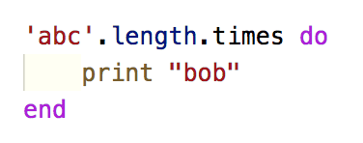

1. In Ruby, what is the syntax for method calls with 0 arguments?
2. Using ***remove_the_vowels****,* write a list comprehension that removes the vowels from each element in the list.

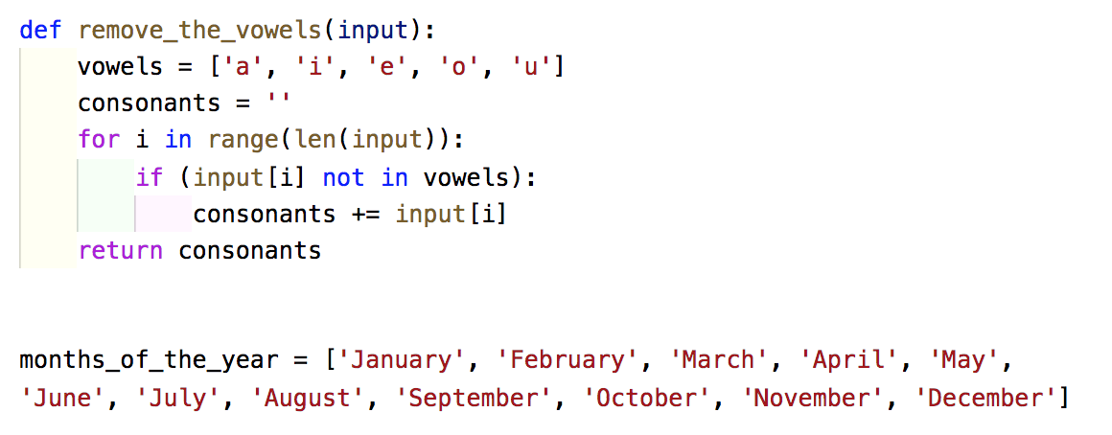

1. What is a higher-ordered function?
2. Describe how map, filter and reduce work?
3. What causes the following exceptions?
   1. MissingMemberException
   2. OverflowException
   3. StackOverflowException
   4. NotImplementedException